

**FPT ACADEMY INTERNATIONAL**

## **FPT – APTECH COMPUTER EDUCATION**



| **Center Name** | | FPT – Aptech – HCM2  Address: 590 Cach Mang Thang Tam, District 3, Ho Chi Minh City | |
| --- | --- | --- | --- |
| **Instructor** |  | Ms. Le Mong Thuy |  |
| **Class** |  | T1.2109.E0 |  |
| **Group** |  | 5 |  |
| **Group members** | | **Name** | **Student ID** |
|  |  | Nguyễn Toán | Student1328430 |
|  |  |  |  |
|  |  | Trương Dương Trúc Duy | Student1333971 |
| **Duration** | Start date | 22th Nov 2021 |  |
| End date | 22th Dec 2021 |  |

**This is to certify that**

**Mr.:**

**Nguyễn Toán**

**Ms:**

**Trương Dương Trúc Duy**

**has successfully designed & developed**

**eProject: Prime Fitness**

**Submitted by:**

**Nguyễn Toán**

**Date of issue:**

**22th Nov 2021**

**Authorized Signature:**



**FPT-APTECH COMPUTER EDUCATION 1**

**ACKNOWLEGMENT 3**

**SYNOSIS 3**

**PROBLEM DEFINITION 3**

**CUSTOMER’S REQUIREMENTS SPECIFICATION (CRS) 4**

**Business/project Objective 4**

**Hardware/software Requirements 5**

**SCOPE OF THE WORK (IN BRIEF) 6**

**Architecture and design of the system 7**

**Diagram of website 8**

**TASK SHEET REVIEW 1 9**

**SITE MAP 10**

**MOCK OF THE WESITE 11**

**1. Logo 11**

**2. Home page 12**

**3. Services 13**

**4. Gallery 14**

**5. Equipments 15**

**6. FAQs**

**7. About Us**

**7. Enquiry 17**

**8. Member 18**

**TASK SHEET REVIEW 2 19**

**WEBSITE DISCRIPTION 20**

**1. Logo 11**

**2. Home page 12**

**3. Services 13**

**4. Gallery 14**

**5. Equipments 15**

**6. FAQs**

**7. About Us**

**7. Enquiry 17**

**8. Member 26**

**JAVASCRIPT DISCRIPTION 27**

**1. Product data json and javascript 27**

**2. Filter javascript 30**

**3. Comparison javascript // 31**

**4. Add to cart javascript 34**

**5. Contact us javascript 35**

**TASK SHEET REVIEW 3 36**

# **ACKNOWLEDGMENT**

On behalf of all members of group 5. First of all, I would like to thank you for receiving this interesting topic from FPT Aptech. Second, we would like to thank Ms. Le Mong Thuy, she has guided us with her enthusiasm and strictness, because of her guidance, we would be able to finish this project. Finally , we thank the whole team for their hard work during the past 4 weeks. Through this project, we have learned more knowledge and applied the knowledge we have learned. This project helps us have a more comprehensive view of the website interface.

# **SYNOPSIS**

# In this task, we are assigned to design and develop a business website which meets all the requirements from our client under the name Prime Fitness Club. The business is a fitness services provider. Prime Fitness Club ltd focused on staying fit is most important to meet the challenging requirements.The purpose of the website is to provide information to customers about Prime Fitness services. What interesting experiences will customers have when participating? Not only, customers will maintain a slim, toned, healthy body. But also, customers will feel comfortable, happy, relieve all stress and fatigue in life

# **PROBLEM DEFINITION**

# The Web site is to be created based on the following requirements.

# The Home page should be designed with the appropriate template and navigation link.

# Designing and navigation both must be made user friendly.

# Links can be:

# - Cycling.

# - Swimming.

# - Sports & Fitness.

# - Group Exercise.

# - Membership.

# - Salon & Spa.

# - Gallery.

# - List of equipment with its description.

# About us. There should be a “Contact Us” page which will have the Address of the Company which should be displayed using Geolocation API (e.g. Google Maps) and the email address which when clicked will invoke the local mail client from where they can send an email.

# FAQs.

# Enquiry Form.

# Site Map.

# **CUSTOMER'S REQUIREMENTS SPECIFICATIONS (CRS)**

**Client: Prime Fitness Club**

### **Business/Project Objective:**

Prime Fitness is a fitness club established in the year 1982. The fitness club has been equipped with all basic fitness equipment and also included the newly introduced. The Prime Fitness club is the flagship brand for Prime Fitness Club Ltd, a UN based health and fitness services provider and a pioneer in the “Integrated Health Club Management Solutions’ business. Prime Fitness Club ltd focuses on staying fit is most important to meet the challenging requirements.

The website is to be developed for the Windows Platform using HTML5, JavaScript and Geolocation. The site should work well in all leading browsers including Chrome, IE, Firefox etc.

**Input to the system:**

* Searching products of gift item: mugs, clocks, perfumes, stuffed animals, jelwery accessories.

**Output from the system:**

* A logo and navigation bars ontop.
* Display the list of available gifts category wise.
* Perform the search based on a particular: mugs, perfurme, jewelry accessories, stuffed animals, clock.
* Display the best seller monthly.
* Display the various offers by the shop.
* Display the details of item (brand, material, price, etc.).
* Give information about product.
* Site should be able to provide brief infomation of business(history, country, members...).
* The location of the shop under Contact-Us page.

**Progress:**

* In the Shop site, users can use filter to sort type of products.
* We allow user to select and compare product in specific categories.

**Expected delivery date:** 22th-December-2021.

**List of deliverables:**

* + - * Document Word.
      * Source code.

### **Hardware/ Software Requirements:**

* **For developer**

**Hardware**

* + A minimum computer system that will help you access all the tools in the
  + courses is a Pentium 166 or better
  + 64 Megabytes of RAM or better

**Software**

* + Notepad/HTML editor
  + Dreamweaver
  + IE 5.0/ Netscape 6.0.
* **For web users**

**Hardware**

* + A minimum computer system that will help you access all the tools in the
  + courses is a Pentium 166 or better
  + 64 Megabytes of RAM or better

**Software**

* + Notepad/HTML editor
  + Dreamweaver
  + IE 5.0/ Netscape 6.0.

# **SCOPE OF THE WORK (IN BRIEF)**

After a long and detailed discussion, our group has decided to create a website contain the following webpages:

1. **Homepage**: We divided the section into 3 parts:
   * + *Part 1: Display section in carousel/slides: new arrivals/promotion/seasonal event.*
     + *Part 2: Display menu best seller items.*
     + *Part 3: Customer Feedback (display images)*
2. **Shop**: Display all items, compare and filter to sort items in specific categories and brands.
3. **Features**: Display downloadable documents (manual/visual instruction) or display embedded video on page.
4. **AboutUs**: Display business information and client review (persuasive reasons to choose our business).
5. **Contact**: Display business contacts (address, phone, email, map).

# **Architecture and design of the system**

Webpage request

# **Diagram of the website**

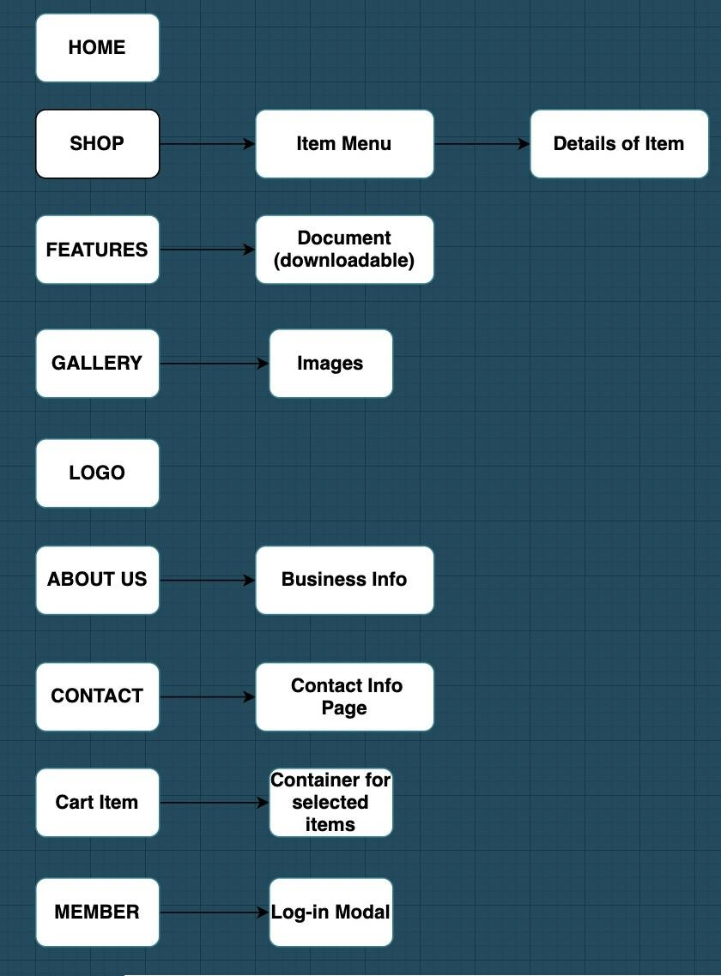



# **TASK SHEET REVIEW 1**

| **Project Ref. No.:**  **eP/Advertisement Portal Management**  **System/01** | | **Project Title:** | **Activity Plan Prepared By:** | **Date of Preparation of Activity Plan:** | | | |
| --- | --- | --- | --- | --- | --- | --- | --- |
| **Sr.**  **No.** | **Task** | **Actual**  **Start Date** | **Actual Days** | **Team Mate Names** | **Status** |
| 1 | Problem Statement | GIFTS SHOP | Đỗ Thành Ân | 15-July-21 | 1 | Đ.T.Ân | Completed |
| 2 | Analysis of Gifts Shop requirements about the website | 15-July-21 | 1 | P.Q.N.Thạch | Completed |
| 3 | The scope of the work (in brief) | 15-July-21 | 1 | P.Q.N.Thạch | Completed |
| 4 | Architecture and design of the system | 15-July-21 | 1 | N.H.Tuấn | Completed |
| 5 | Diagram of the website | 15-July-21 | 1 | N.H.Tuấn | Completed |
| 6 | Task Sheet | 15-July-21 | 1 | Đ.T.Ân | Completed |

| **Date: 15th July 2021** | |
| --- | --- |
| Signature of Instructor:  **Ms. Le Mong Thuy** | Signature of Team Leader:  **Do Thanh An** |

# **SITE MAP**

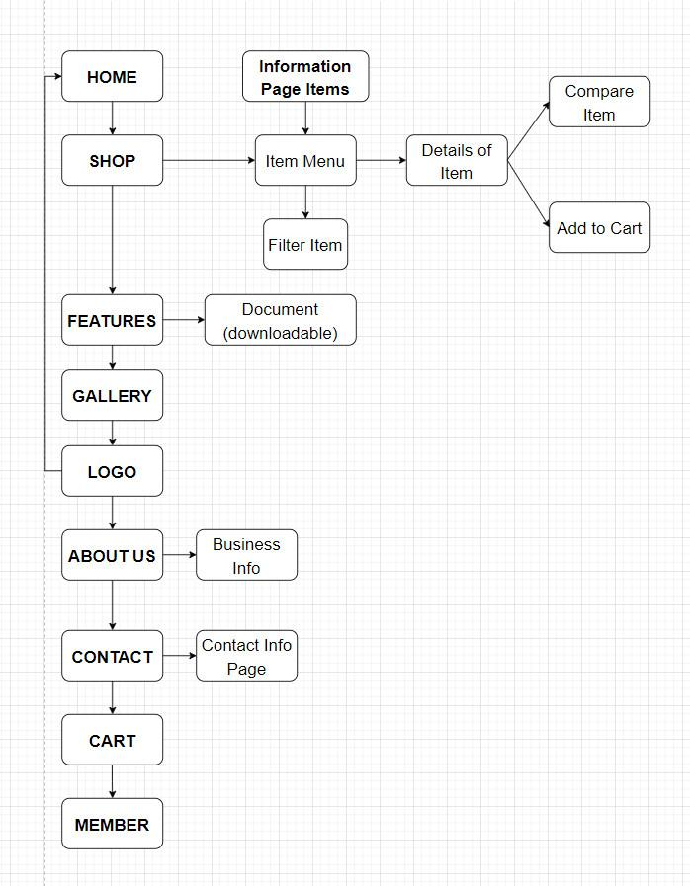

# **MOCK OF THE WEBSITE**

1. **Homepage**

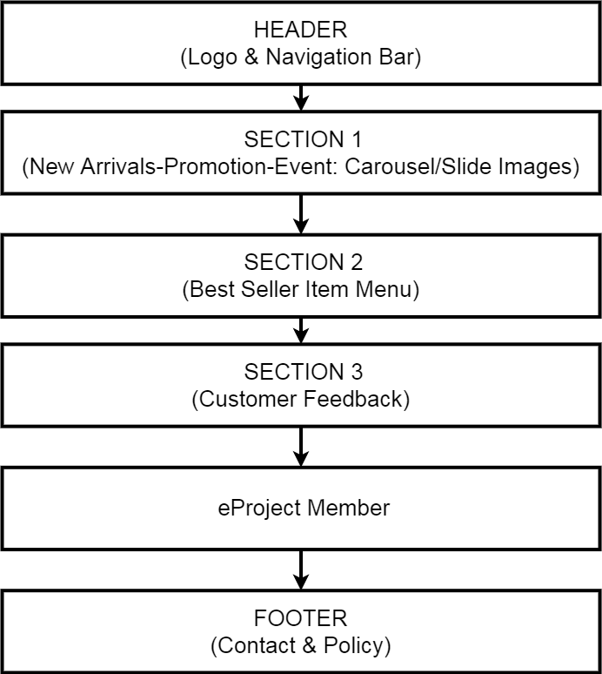

1. **Shop**

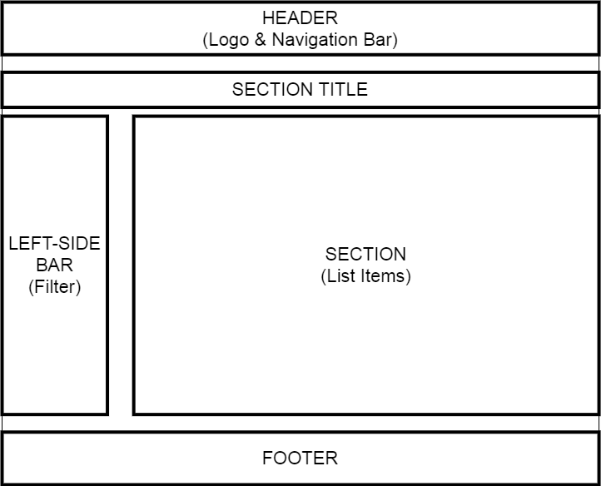

1. **Features**

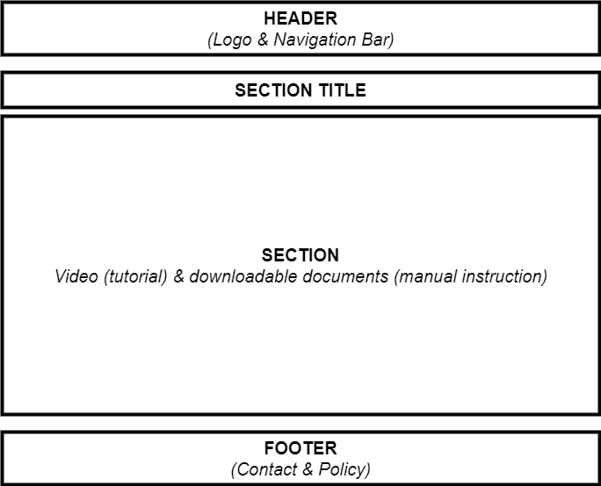

1. **Gallery**

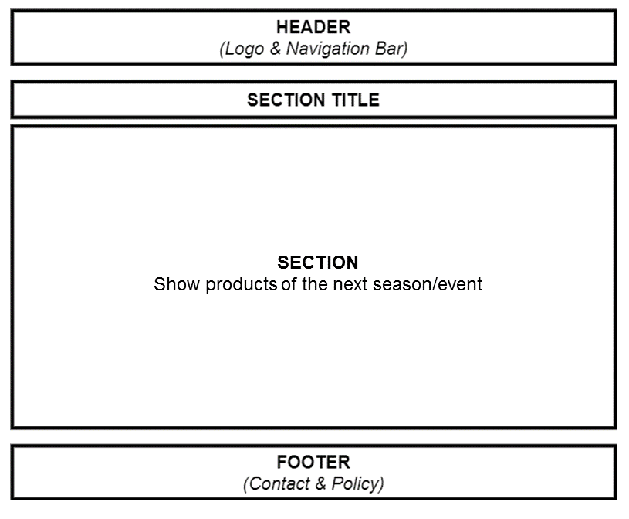

1. **Logo**

This logos designed by Nguyễn Hoàng Tuấn-Student1313762



1. **About us**

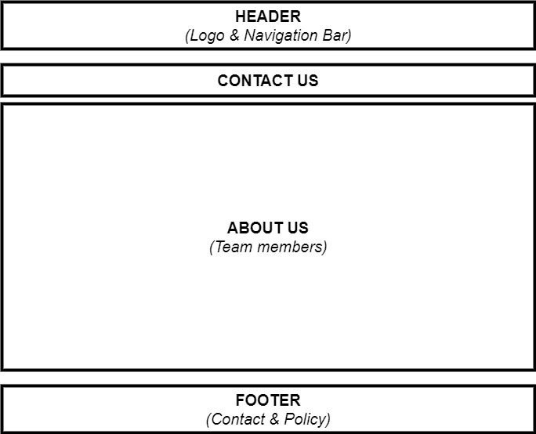

1. **Contact us**

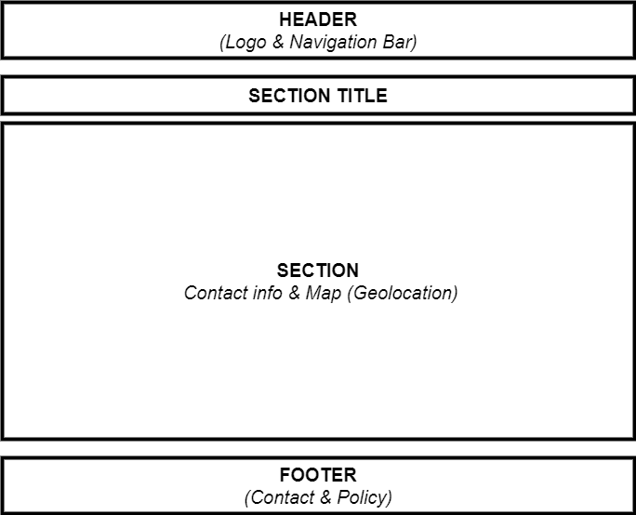

1. **Membership**

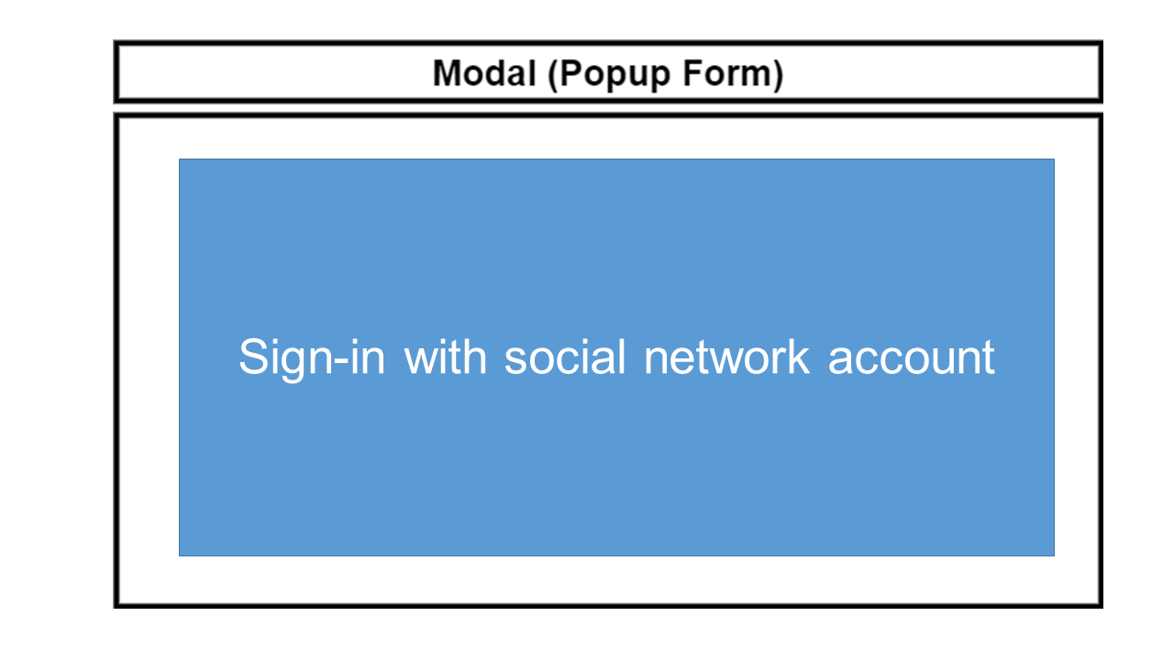

# **TASK SHEET REVIEW 2**

| **Project Ref. No.:**  **eP/Advertisement**  **Portal Management System/01** | | **Project Title:** | **Activity Plan Prepared By:** | **Date of Preparation of Activity Plan:** | | | |
| --- | --- | --- | --- | --- | --- | --- | --- |
| **Sr.**  **No.** | **Task** | **Actual Start Date** | **Actual Days** | **Team Mate Names** | **Status** |
| 1 | Site map | GIFT  SHOP | Đỗ Thành Ân | 16th-July-2021 | 1 | P.Q.N.Thạch | Completed |
| 2 | Mock of the website | 16th-July-2021 | 2 | N.H.Tuấn | Completed |
| 3 | Task sheet | 16th-July-2021 | 2 | Đ.T.Ân | Completed |

| **Date: 19th July 2021** | |
| --- | --- |
| Signature of Instructor:  **Ms. Le Mong Thuy** | Signature of Team Leader:  **Do Thanh An** |

**WEBSITE DESCRIPTION**

1. **Home page**
2. Description

Home page displays following infomation

* + - Events
    - Best Seller
    - Feedbacks
  1. Screenshot

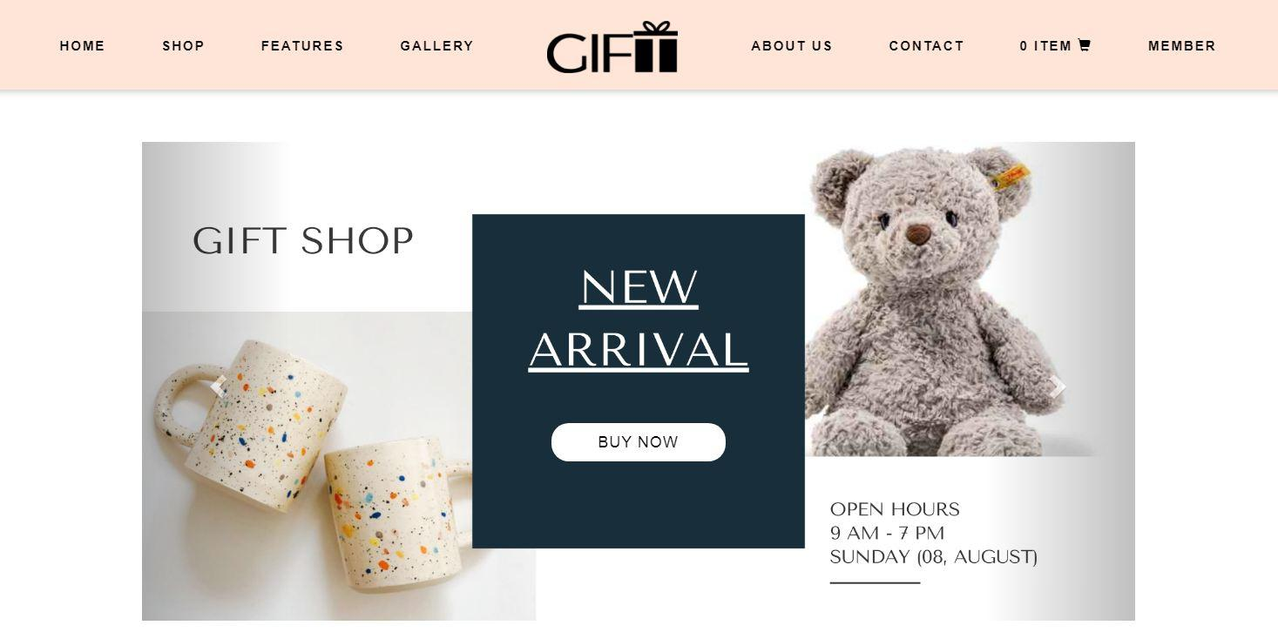

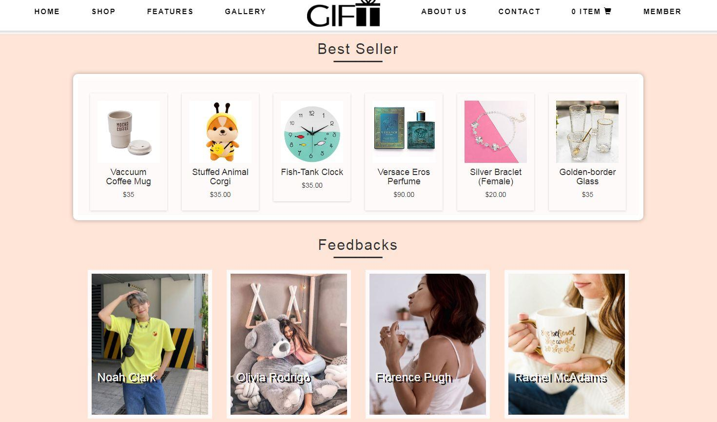



1. **Shop**
   1. Description

Shop page displays following infomation

* + - Show all products at Shop page.
    - Show all product categories:

+ Mug.

+ Jewelry

+ Clock

+ Stuffed animal

+ Perfume

* 1. Screenshot

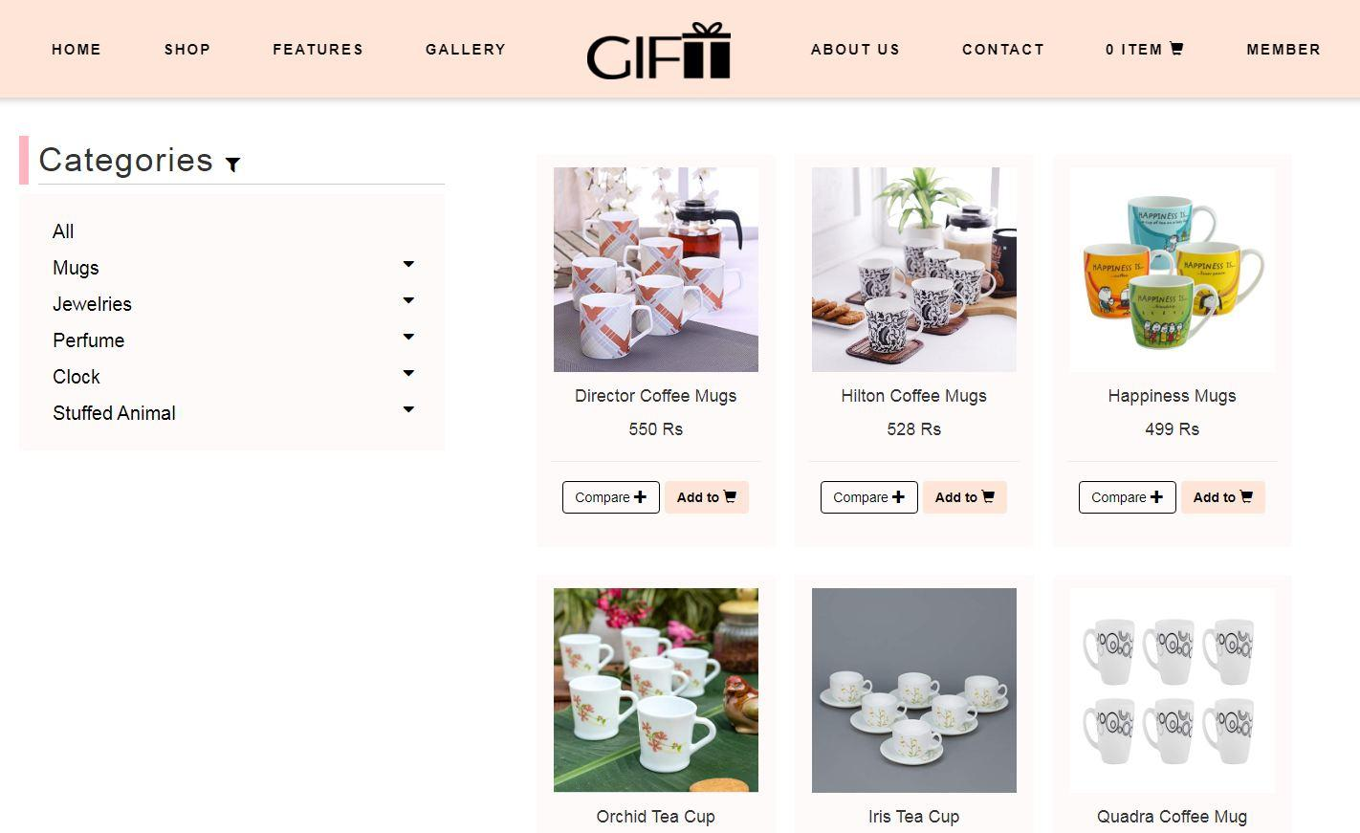

1. **Product categories**
   1. Description

Product category pages displays following infomation

* + - Show all products of category.
    - Filter by brands and categories.
  1. Screenshot

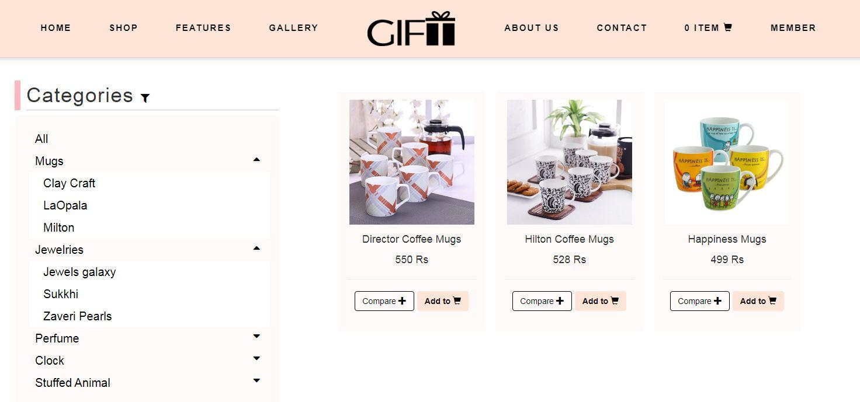

1. **Featuers** 
   1. Description

This page displays a brief summary of features of individual products.

* 1. Screenshot

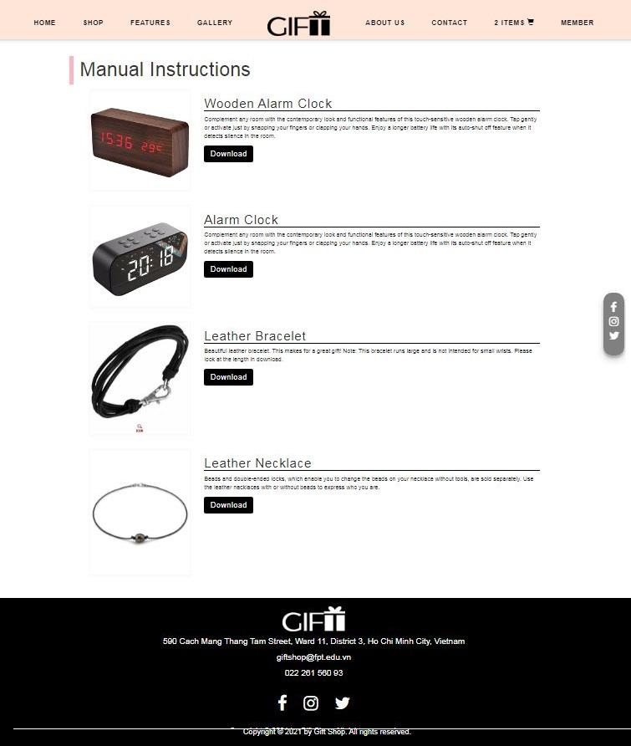

1. **Gallery**
   1. Description

This page will displays information about new products of the next season/event.

* 1. Screenshot

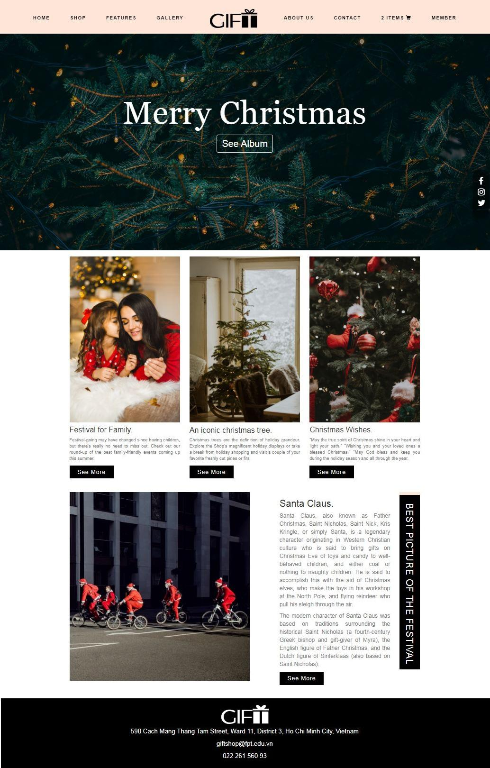

1. **About us**
   1. Description

This page will displays information about the history of Gift shop, our service that we provide and our team member.

* 1. Screenshot

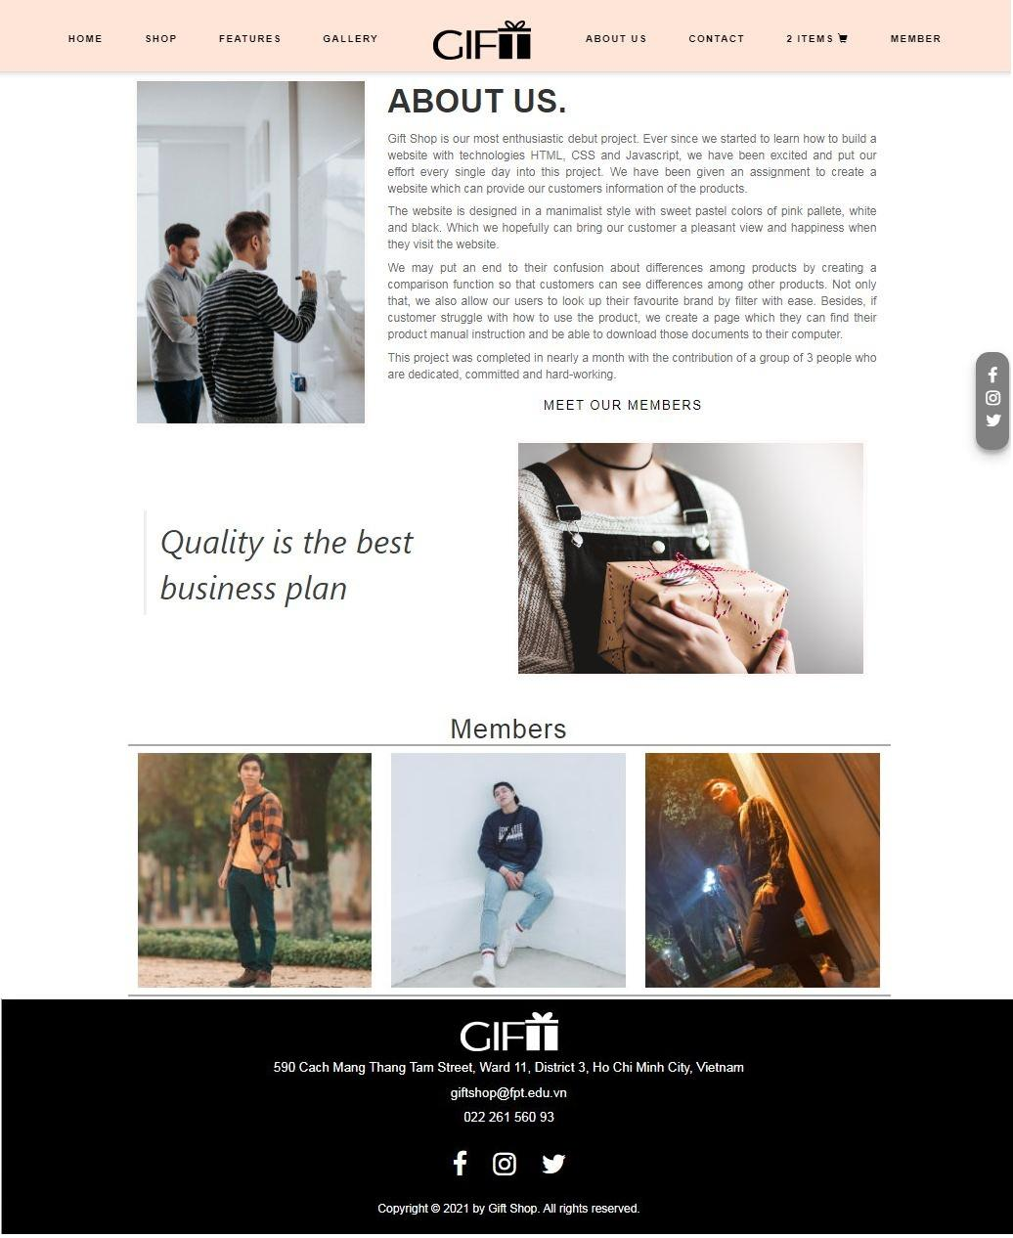

1. **Contact us**
   1. Description

This page displays contact information: location, telephone number, email and a quick contact form for customer.

* 1. Screenshot

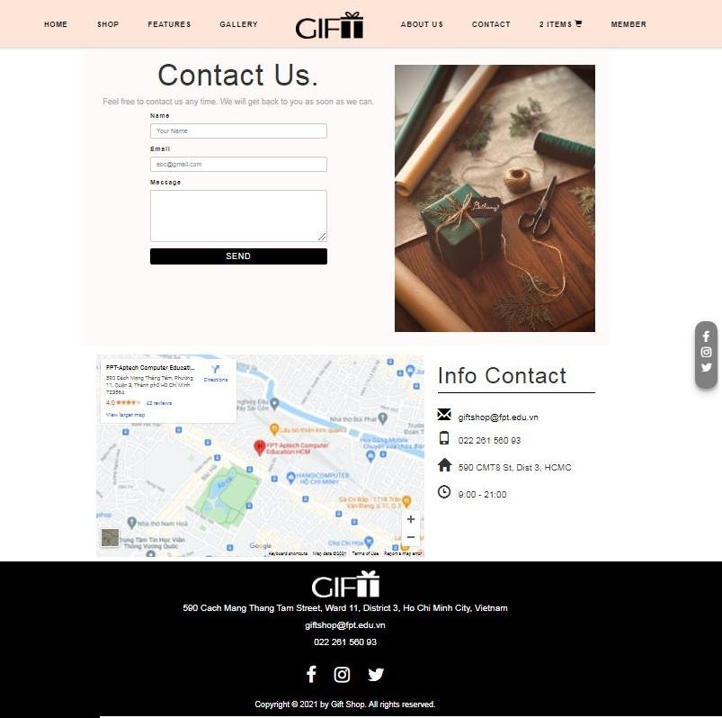

1. **Member** 
   1. Description

This modal displays 2 types of login:

- Login with account which registed directly at local shop.

- Login with social network account.

* 1. Screenshot

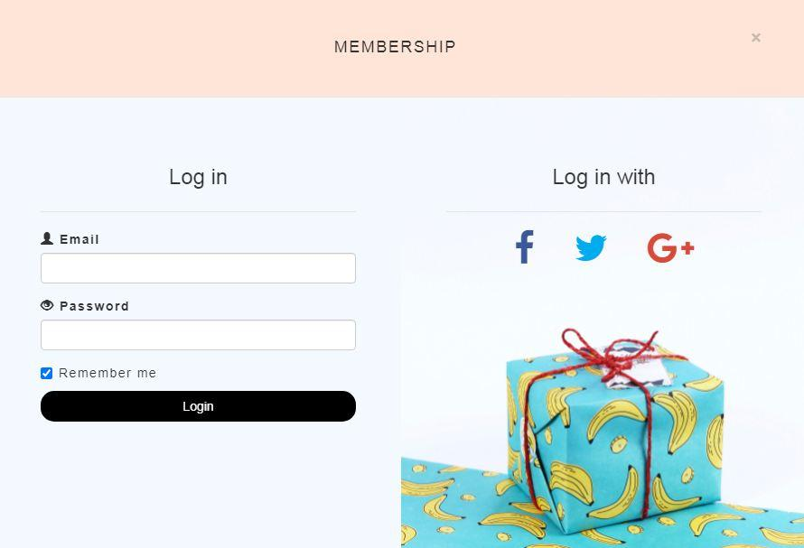

**JAVASCRIPT DESCRIPTION**

1. **Product data json and javascript.**
   1. Description

This script used for adding product detail.

* 1. Screenshot

b-1 Product data json

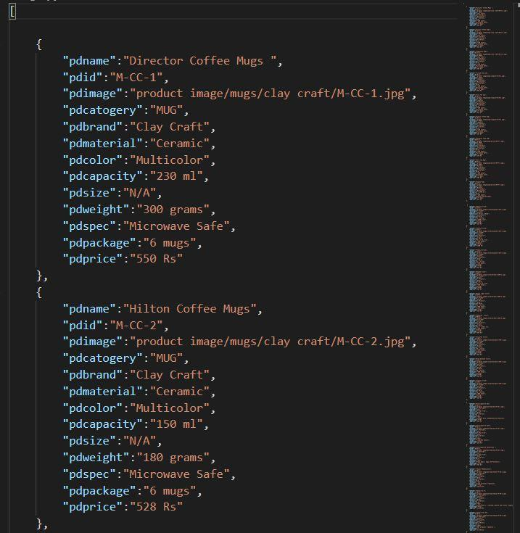

b-2 Javascript

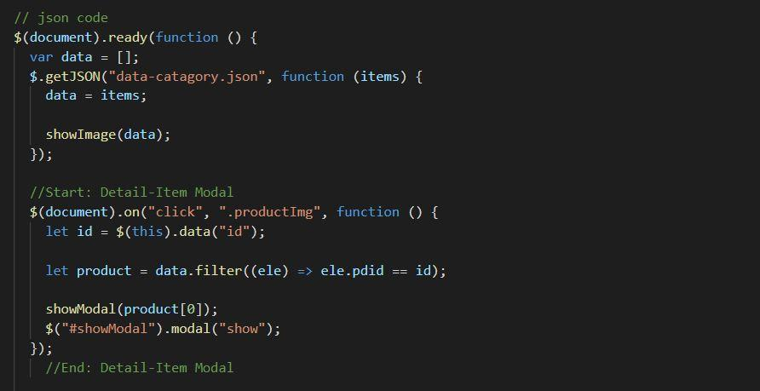

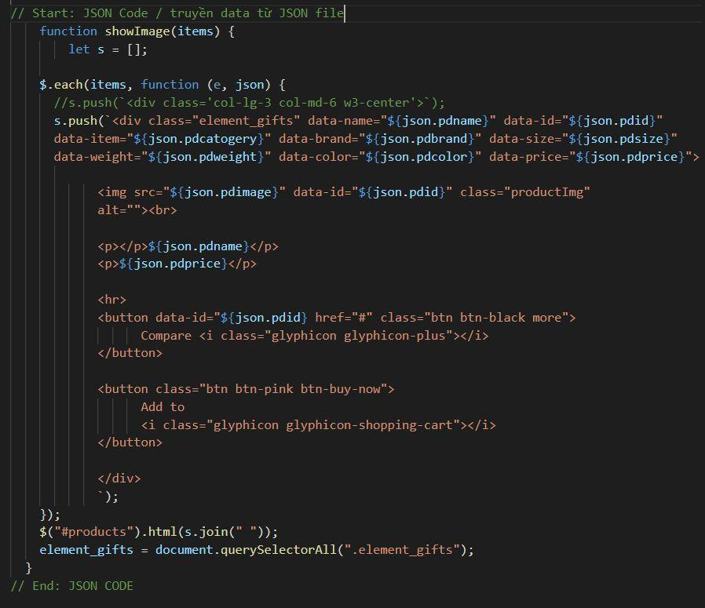

b-3 Modal show item’s detail

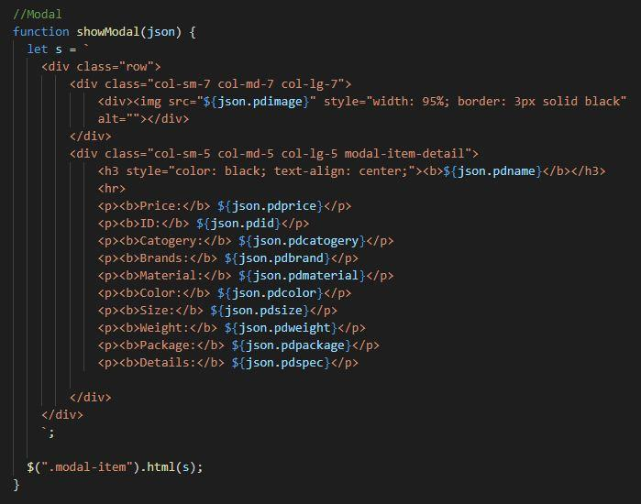

1. **Filter javascript**
   1. Description

This script used for filtering items in the shop page based on categories and brands

* 1. Screenshot

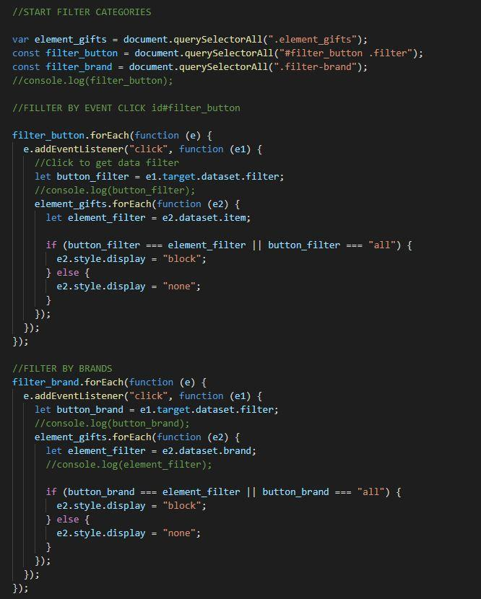

1. **Comparison javascript**
   1. Description

This script used for comparing items in the shop page based on categories and brands

* 1. Screenshot

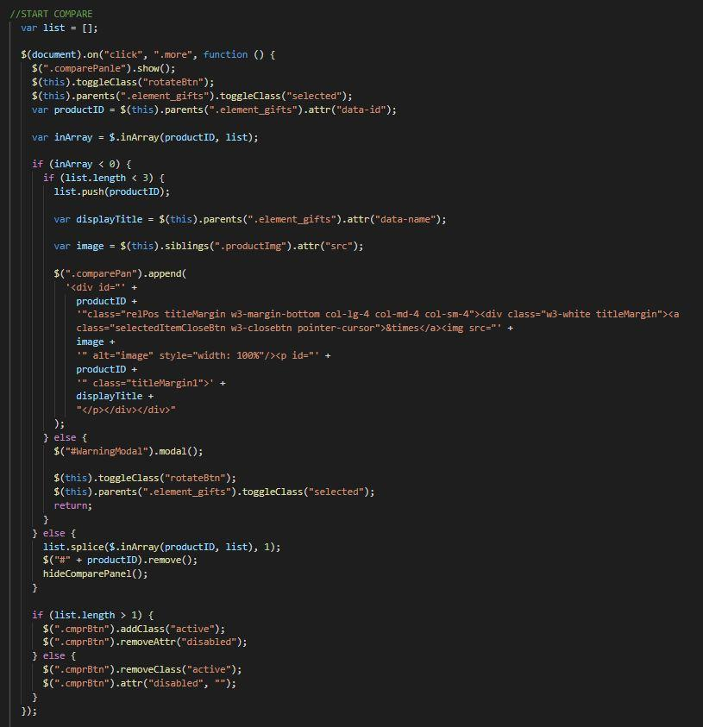

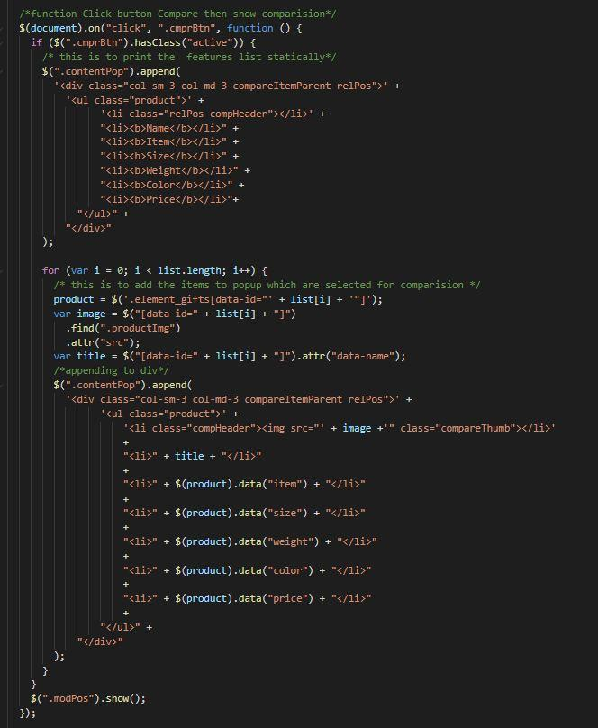

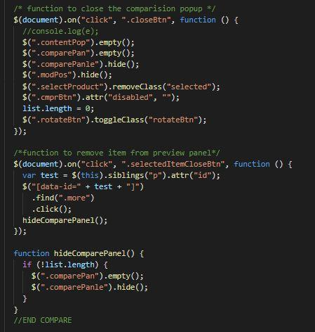

1. **Add to Cart javascript**
   1. Description

This script used for adding items to cart and show how many item added.

* 1. Screenshot

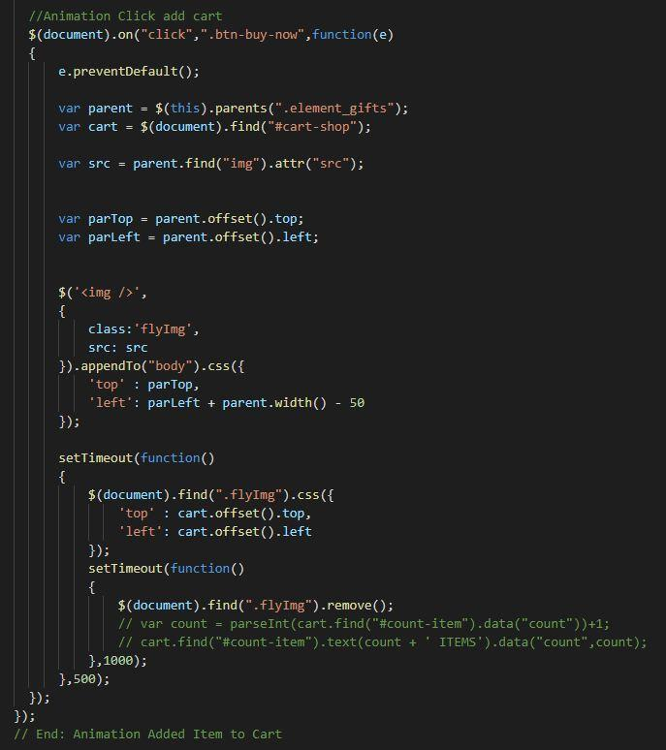

1. **Contact us javascript**
   1. Description

This script used for contacting to our customer service.

* 1. Screenshot

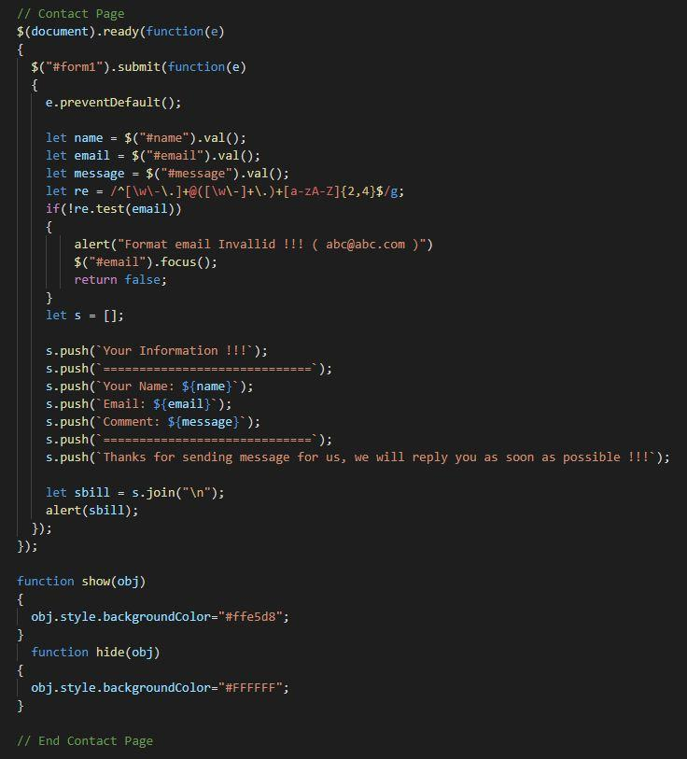

**TASK SHEET REVIEW 3**

| **Project Ref. No.:**  **eP/Advertisement**  **Portal Management System/01** | | **Project Title:** | **Activity Plan Prepared By:** | **Date of Preparation of Activity Plan:** | | | |
| --- | --- | --- | --- | --- | --- | --- | --- |
| **Sr.**  **No.** | **Task** | **Actual Start Date** | **Actual Days** | **Team Mate Names** | **Status** |
| 1 | Website layout | GIFT  SHOP | Đỗ Thành Ân | 20th-July-2021 | 5 | N.H.Tuấn | Completed |
| 2 | Edit CSS | 20th-July-2021 | 5 | N.H.Tuấn | Completed |
| 3 | Modal javascript | 23th-July-2021 | 5 | P.Q.N.Thạch | Completed |
| 4 | Filter & comparison javascript | 23th-July-2021 | 5 | P.Q.N.Thạch | Completed |
| 5 | Product detail and data json | 20th-July-2021 | 3 | Đ.T.Ân | Completed |
| 6 | Task sheet review | 06th-Aug-2021 | 3 | Đ.T.Ân | Completed |

| **Date: 06th August 2021** | |
| --- | --- |
| Signature of Instructor:  **Ms. Le Mong Thuy** | Signature of Team Leader:  **Do Thanh An** |